Year 12 Electromagnetism 2

revision sheet

**Section 1 Short response (15 marks)**

1. A single loop of wire is passed through the iron core of a transformer as shown in the diagram below. This loop forms the primary circuit. The secondary winding has 50 turns.

A steady current of 10.0 mA DC is flowing in the primary circuit in the direction shown by the arrow.



a) Draw, on the diagram, an arrow to indicate the direction of the magnetic field at P, created by the current in the primary circuit.

(1 mark)

b) The current in the primary circuit is steadily increased over 0.0500 seconds, causing the magnetic flux threading the loops to increase by 0.00500 Wb.

What is the emf induced in the **secondary** circuit?

(3 marks)

2. A set of door chimes is activated from the 6.00 V output of a step-down transformer. The

transformer primary input is at 240 V and has a current of 1.00 x 10-1 A. The primary coil has 120 turns. Calculate the current flowing through the door chimes from the transformer if the transformer is 90% efficient.

(3 marks)

3. The 'black box' on the power lead that connects a standard school laptop computer to the domestic power supply for recharging batteries is marked

TOSHIBA AC ADAPTOR

INPUT: 240V, O·55OA, 5O Hz

OUTPUT: 15.OV, 3·0OA

a) What type of device is this adaptor (be specific).

(2 marks)

b) Calculate its efficiency.

(2 marks)

4. When a high potential difference is applied between the anode and cathode, shown below, a stream of electrons can be made to flow from the cathode to the anode. An external magnetic field could be applied to this set-up to deflect this stream to the point marked **x**.

a) Describe the position of magnets that cause this deflection.

(2 marks)

b) Use appropriate symbols to display this magnetic field on the diagram above.

(2 marks)

**Section 2 Problem solving (25 marks)**

1. (i) Explain the difference between AC and DC current.

(2)

(ii) What is the structural difference between an AC generator and a DC generator.

(2)

(iii) Explain why AC current is used commercially for distribution to households and industry instead of DC

(3)

(iv) Explain how a simple transformer can step - down the voltage from 132kV mains voltage to 240V for households.

(3)

2. An electrical power grid supplies 66.0 kV to a substation which uses a transformer to provide power at 1500 V to a line to operate a machine in a factory as shown below. The power output from the substation is 120 kW.

The machine is located 100 m from the substation and the average resistance of the circuit wires is 4.00 x 10-3 ohm m-1 (a circuit return wire is also used).

a) What current flows in the factory circuit when the machine is operating?

(3 marks)

b) What is the total power lost in the circuit wires when the machine is operating?

(2 marks)

c) What is the actual operating voltage of the machine?

(2 marks)

3. A pair of parallel metal plates, placed in a vacuum, are separated by a distance of 5.00 × 10−3 m and have a potential difference of 1000 V applied to them.

(a) Calculate the magnitude of the electric field strength between the plates.

(2 marks)

(b) Calculate the magnitude of the electrostatic force acting on an electron between the plates.

(2 marks)

(c) A beam of electrons is fired with a velocity of 3.00 × 106 ms−1 between two plates placed 8.00 cm apart as shown. A magnetic field is applied between the plates, sufficient to cancel the force on the electron beam due to the electric field.

1000 V

Beam of electrons

Calculate the magnitude and direction of the magnetic field required between the plates to stop the deflection of the electron beam.

(4 marks)

**Section 3 Comprehension (10 marks)**

Power stations burn coal to heat water to produce steam. This steam turns the turbine which spins a massive magnet inside a very large coil of wire. As the magnet spins, electricity is induced in the coil of wire.

**Inside the generator**

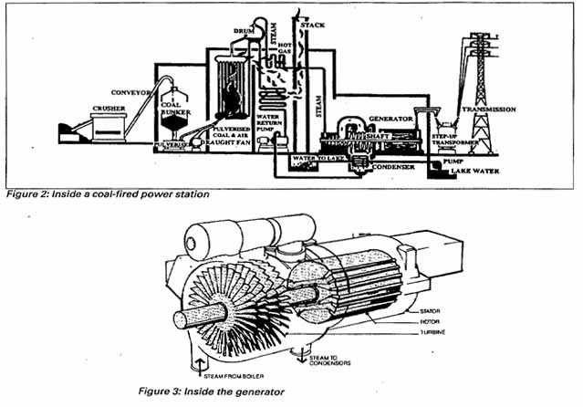A generator turns mechanical energy into electrical energy. The turbine turns a *rotor* which consists of coils of wire wound on a steel core (see Figure 3 below). An electric current supplied to the rotor produces a magnetic field so that it behaves like a magnet. This is an electromagnet. The rotor turns inside another set of windings called the *stator.* As the rotor turns its magnetic field induces an electric current in the coils of the stator. Because first the north pole and then the south pole cuts the stator windings, the current that flows continually changes its direction. This is an alternating current (AC) generator, sometimes called an alternator. In Australia, there is a complete cycle of flow and reversal 50 times a second, making the supply frequency 50 Hertz.

1. What is the period of the AC cycle due to the rotational speed of the turbine? ( Show a calculation.)

(2 marks)

2. Figure 2 shows a Step-up Transformer between the generator and transmission lines.

a) What is the purpose of this device?

(2 marks)

b) Describe the relationship between the number of windings in the primary and secondary coils that would exist in this device.

(1 mark)

c) These devices require some sort of heat dissipation (ie cooling) design. Why do they get hot?

(2 marks)

3. Why are the coils of the *rotor* wound on a steel core?

(2 marks)

4. The induced emf is produced in the coils of the *stator.* Western Australia power grid generators have three *stators* placed around the *rotor.* Each produces an emf as the *rotor* spins but the resulting electrical cycles are out of phase. A basic law would suggest you could not continually add more *stators* to induce a greater number of separate emf supplies from the same *rotor* without affecting its rotation. **Name** this law.

(l mark)